Table 1.

Impoundments sampled, surface area (ha), years of spring electrofishing, and year(s) of shoreline rotenone application, if any (“control”).

|  |  |  |  |
| --- | --- | --- | --- |
| Impoundment | Size (ha) | Years Electrofished | Year(s) Treated |
| Anderson | 2.8 | 2017, 2018 | control |
| AE1 | 1.6 | 2017, 2018, 2019 | control |
| Big Pit | 11 | 2017, 2018, 2019 | control |
| FP3 | 0.7 | 2017, 2018, 2019 | control |
| Drummond3 | 8.8 | 2018, 2019 | control |
| Meriwether | 3.4 | 2018, 2019 | control |
| Williams | 3.3 | 2018, 2019 | control |
| Promise | 1.9 | 2018, 2019 | control |
| Little Pit | 4 | 2017, 2018, 2019 | 2017, 2018 |
| S3 | 4 | 2017, 2018, 2019 | 2017, 2018 |
| Horseshoe | 1.3 | 2017, 2018, 2019 | 2017, 2018 |
| Drummond1 | 8.7 | 2018, 2019 | 2018 |
| Britton | 2.2 | 2018, 2019 | 2018 |
| Zachry | 5.3 | 2018, 2019 | 2018 |
| Dead | 2.2 | 2018, 2019 | 2018 |



Figure 1.

Map of small impoundments studied in southern Alabama, USA. Controls are grey triangles and treatments are black circles. Horseshoe (treatment), Little Pit (treatment), and Big Pit (control) are all three within 50 meters of each other, so the symbols almost completely overlap.

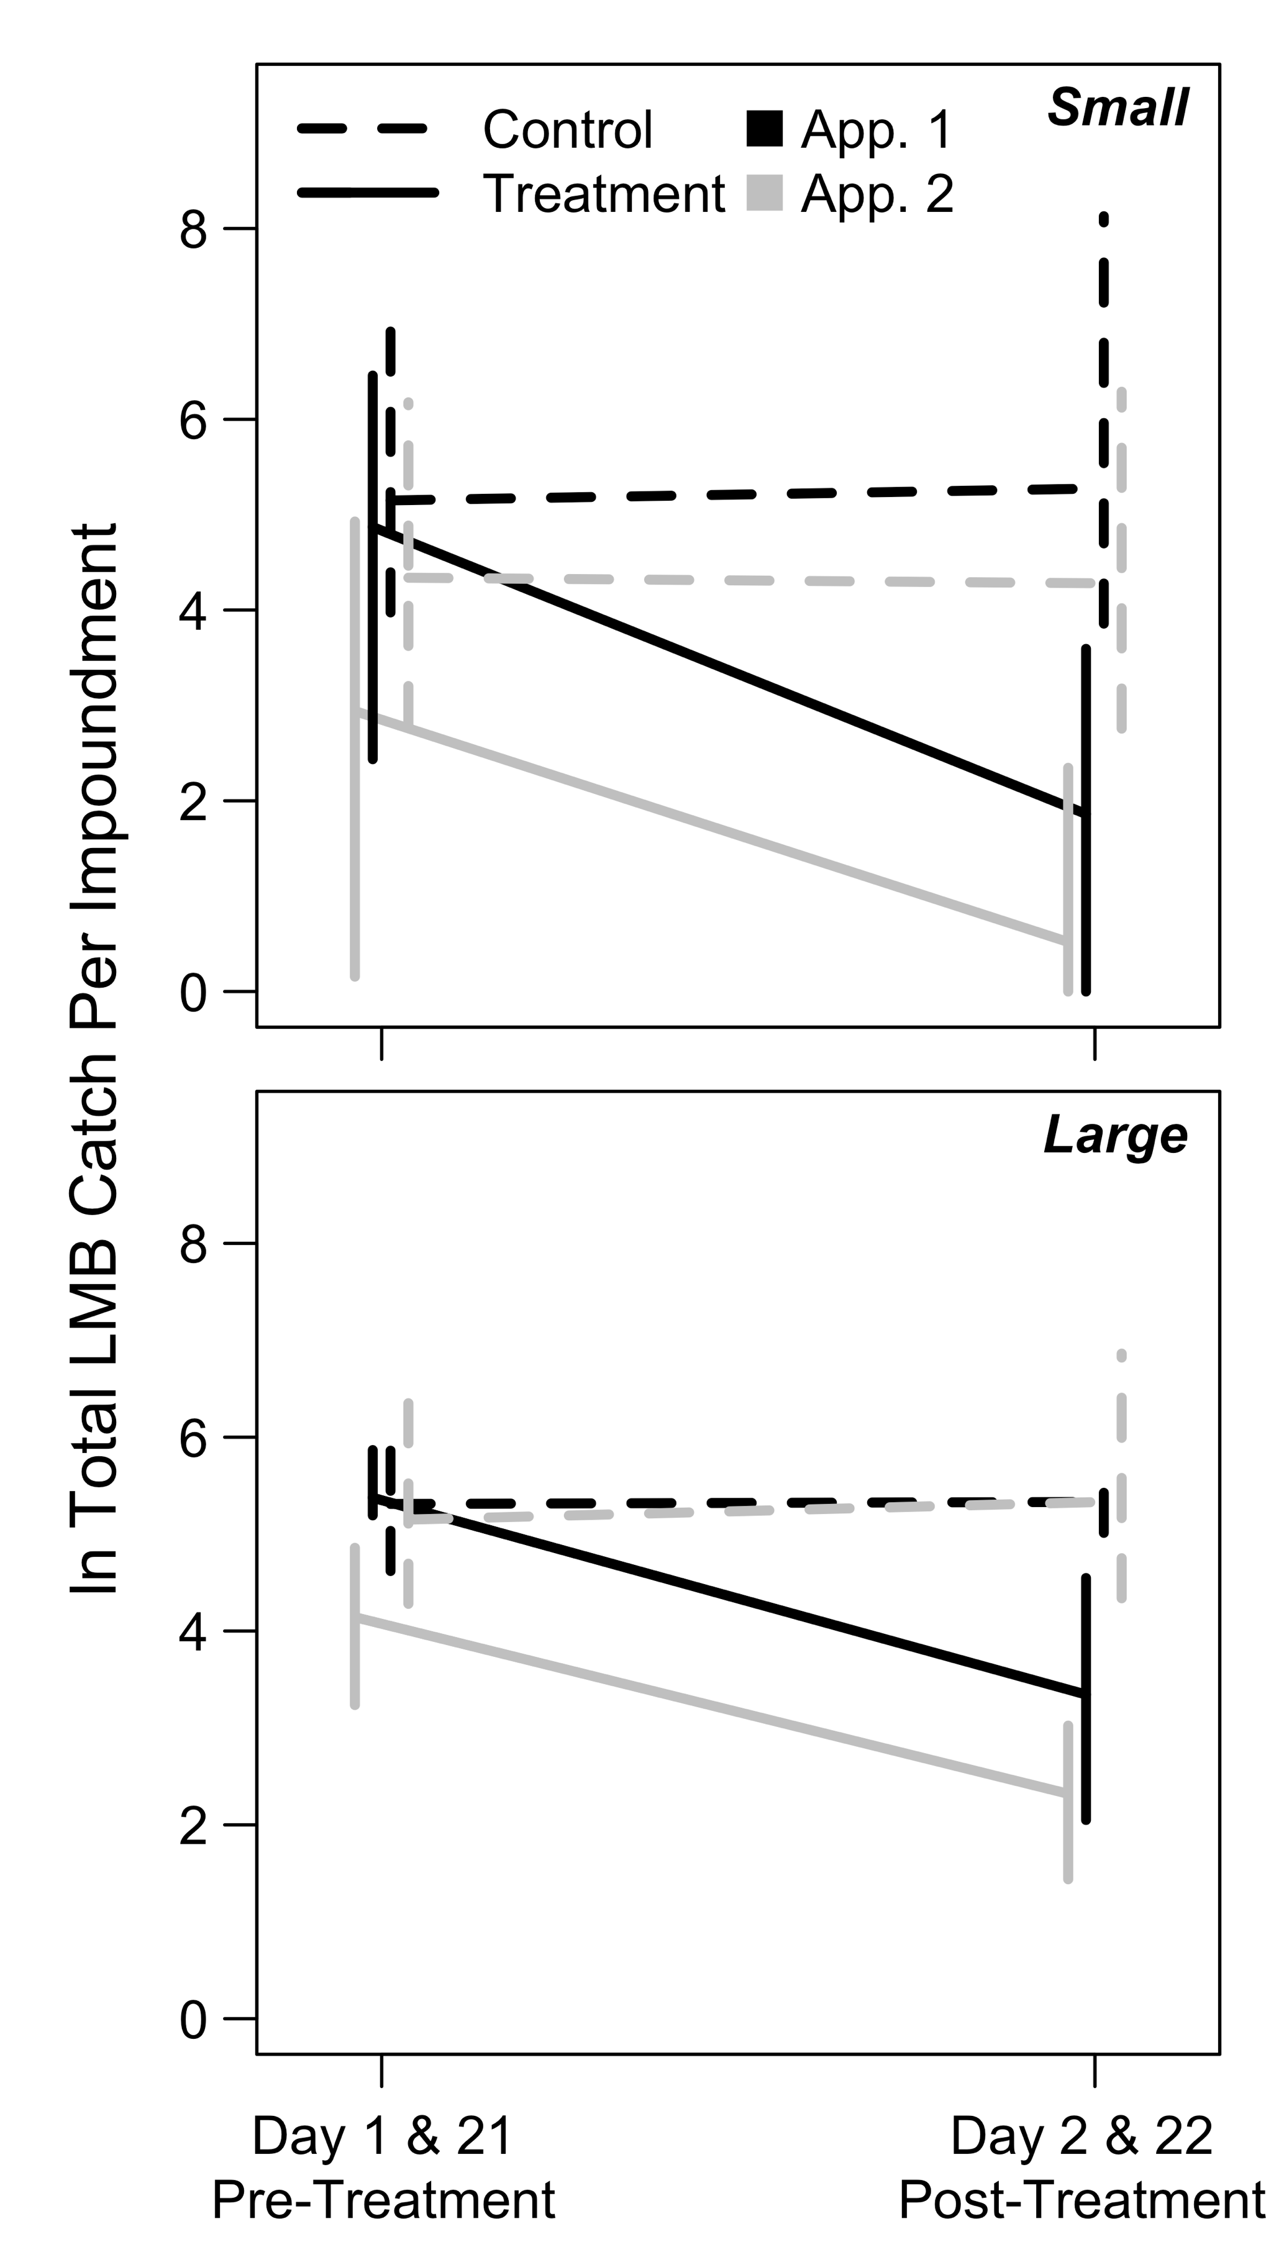

Figure 2.

Largemouth Bass loge total seine catches immediately before (days 1 and 21) and after (days 2 and 22) the first (“App. 1”; black lines) and second (“App. 2”; grey lines) shoreline rotenone applications in small (<12 ha; upper panel) and large (>33 ha; lower panel) impoundments. Solid lines denote treated impoundments and dashed lines denote controls. Observations were pooled across years (2017 and 2018) and error bars represent the 2.5th and 97.5th percentiles (95% confidence intervals).

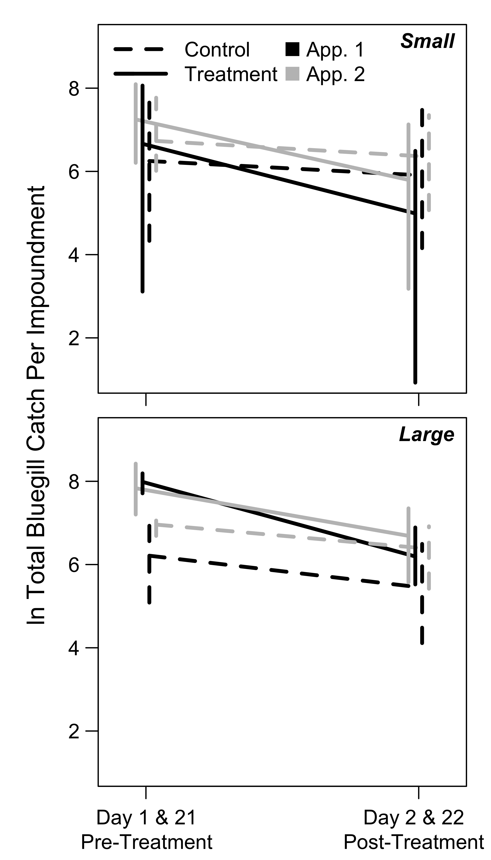

Figure 3.

Bluegill loge total seine catches immediately before (days 1 and 21) and after (days 2 and 22) the first (“App. 1”; black lines) and second (“App. 2”; grey lines) shoreline rotenone applications in small (<12 ha; upper panel) and large (>33 ha; lower panel) impoundments. Data are presented as in Figure 2.

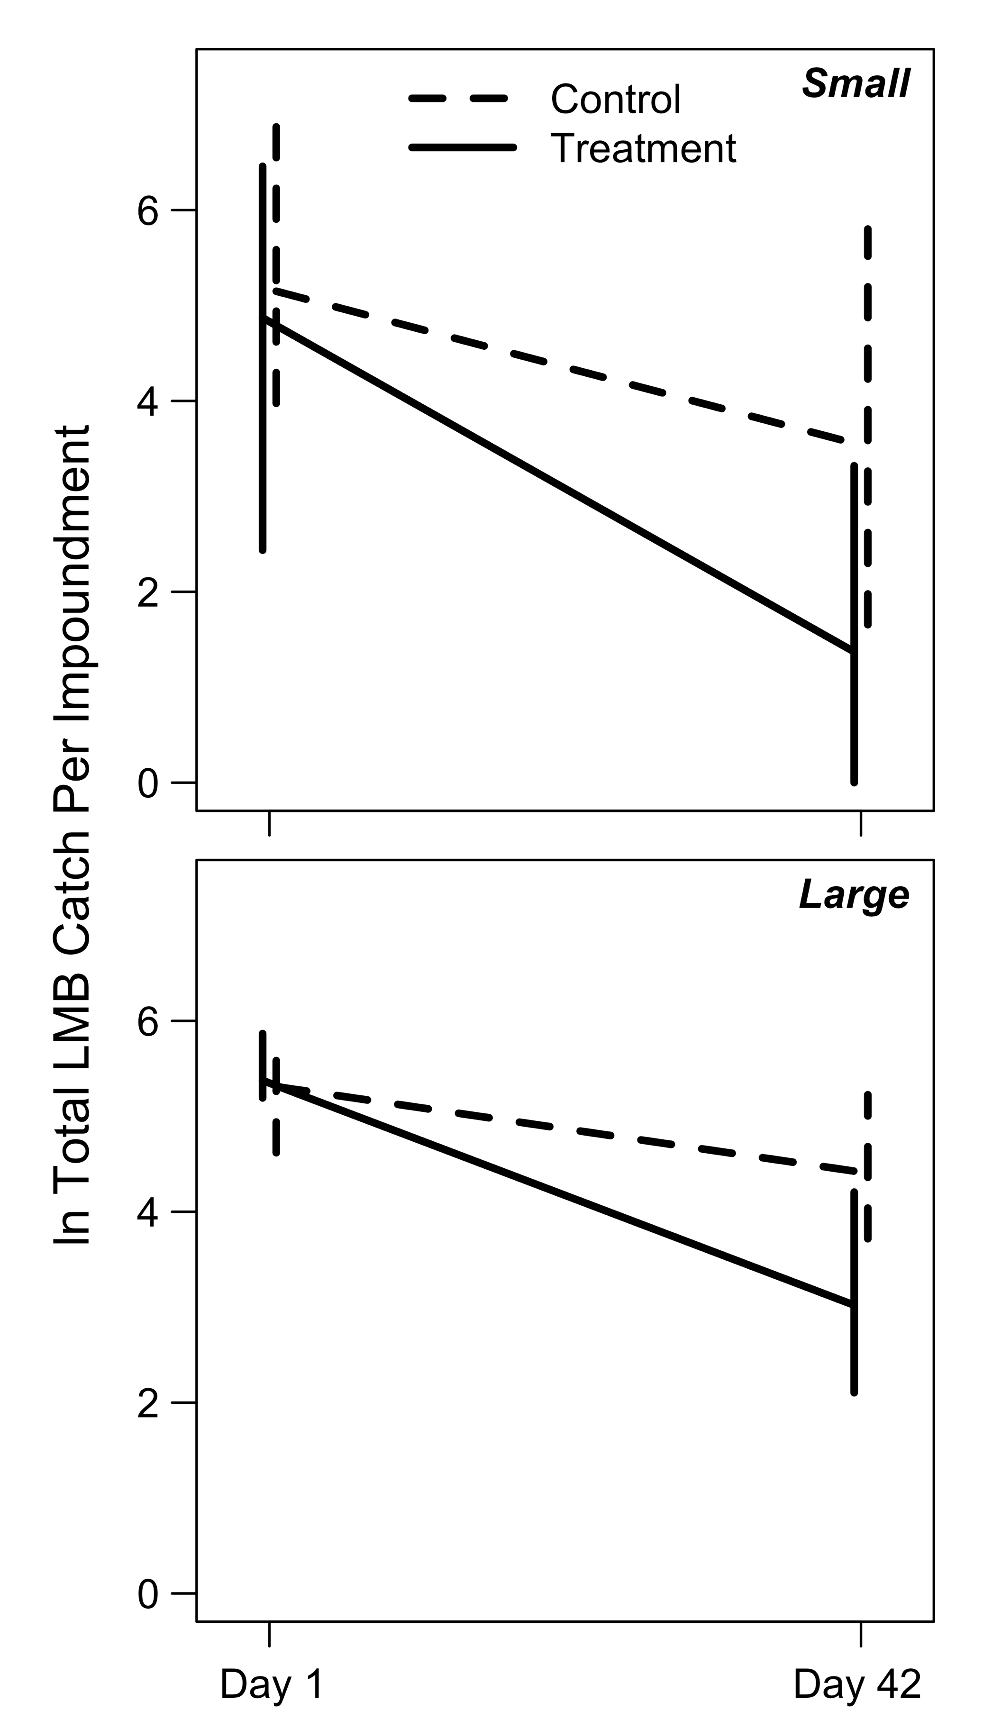

Figure 4.

Largemouth Bass loge total seine catches in small (<12 ha; upper panel) and large (>33 ha; lower panel) impoundments immediately before rotenone application (day 1) and at mid-summer after both rotenone applications (day 42). Solid lines denote impoundments that received shoreline rotenone treatments, and dashed lines denote controls. Data were pooled across years (2017, 2018) and error bars represent 95% confidence intervals.

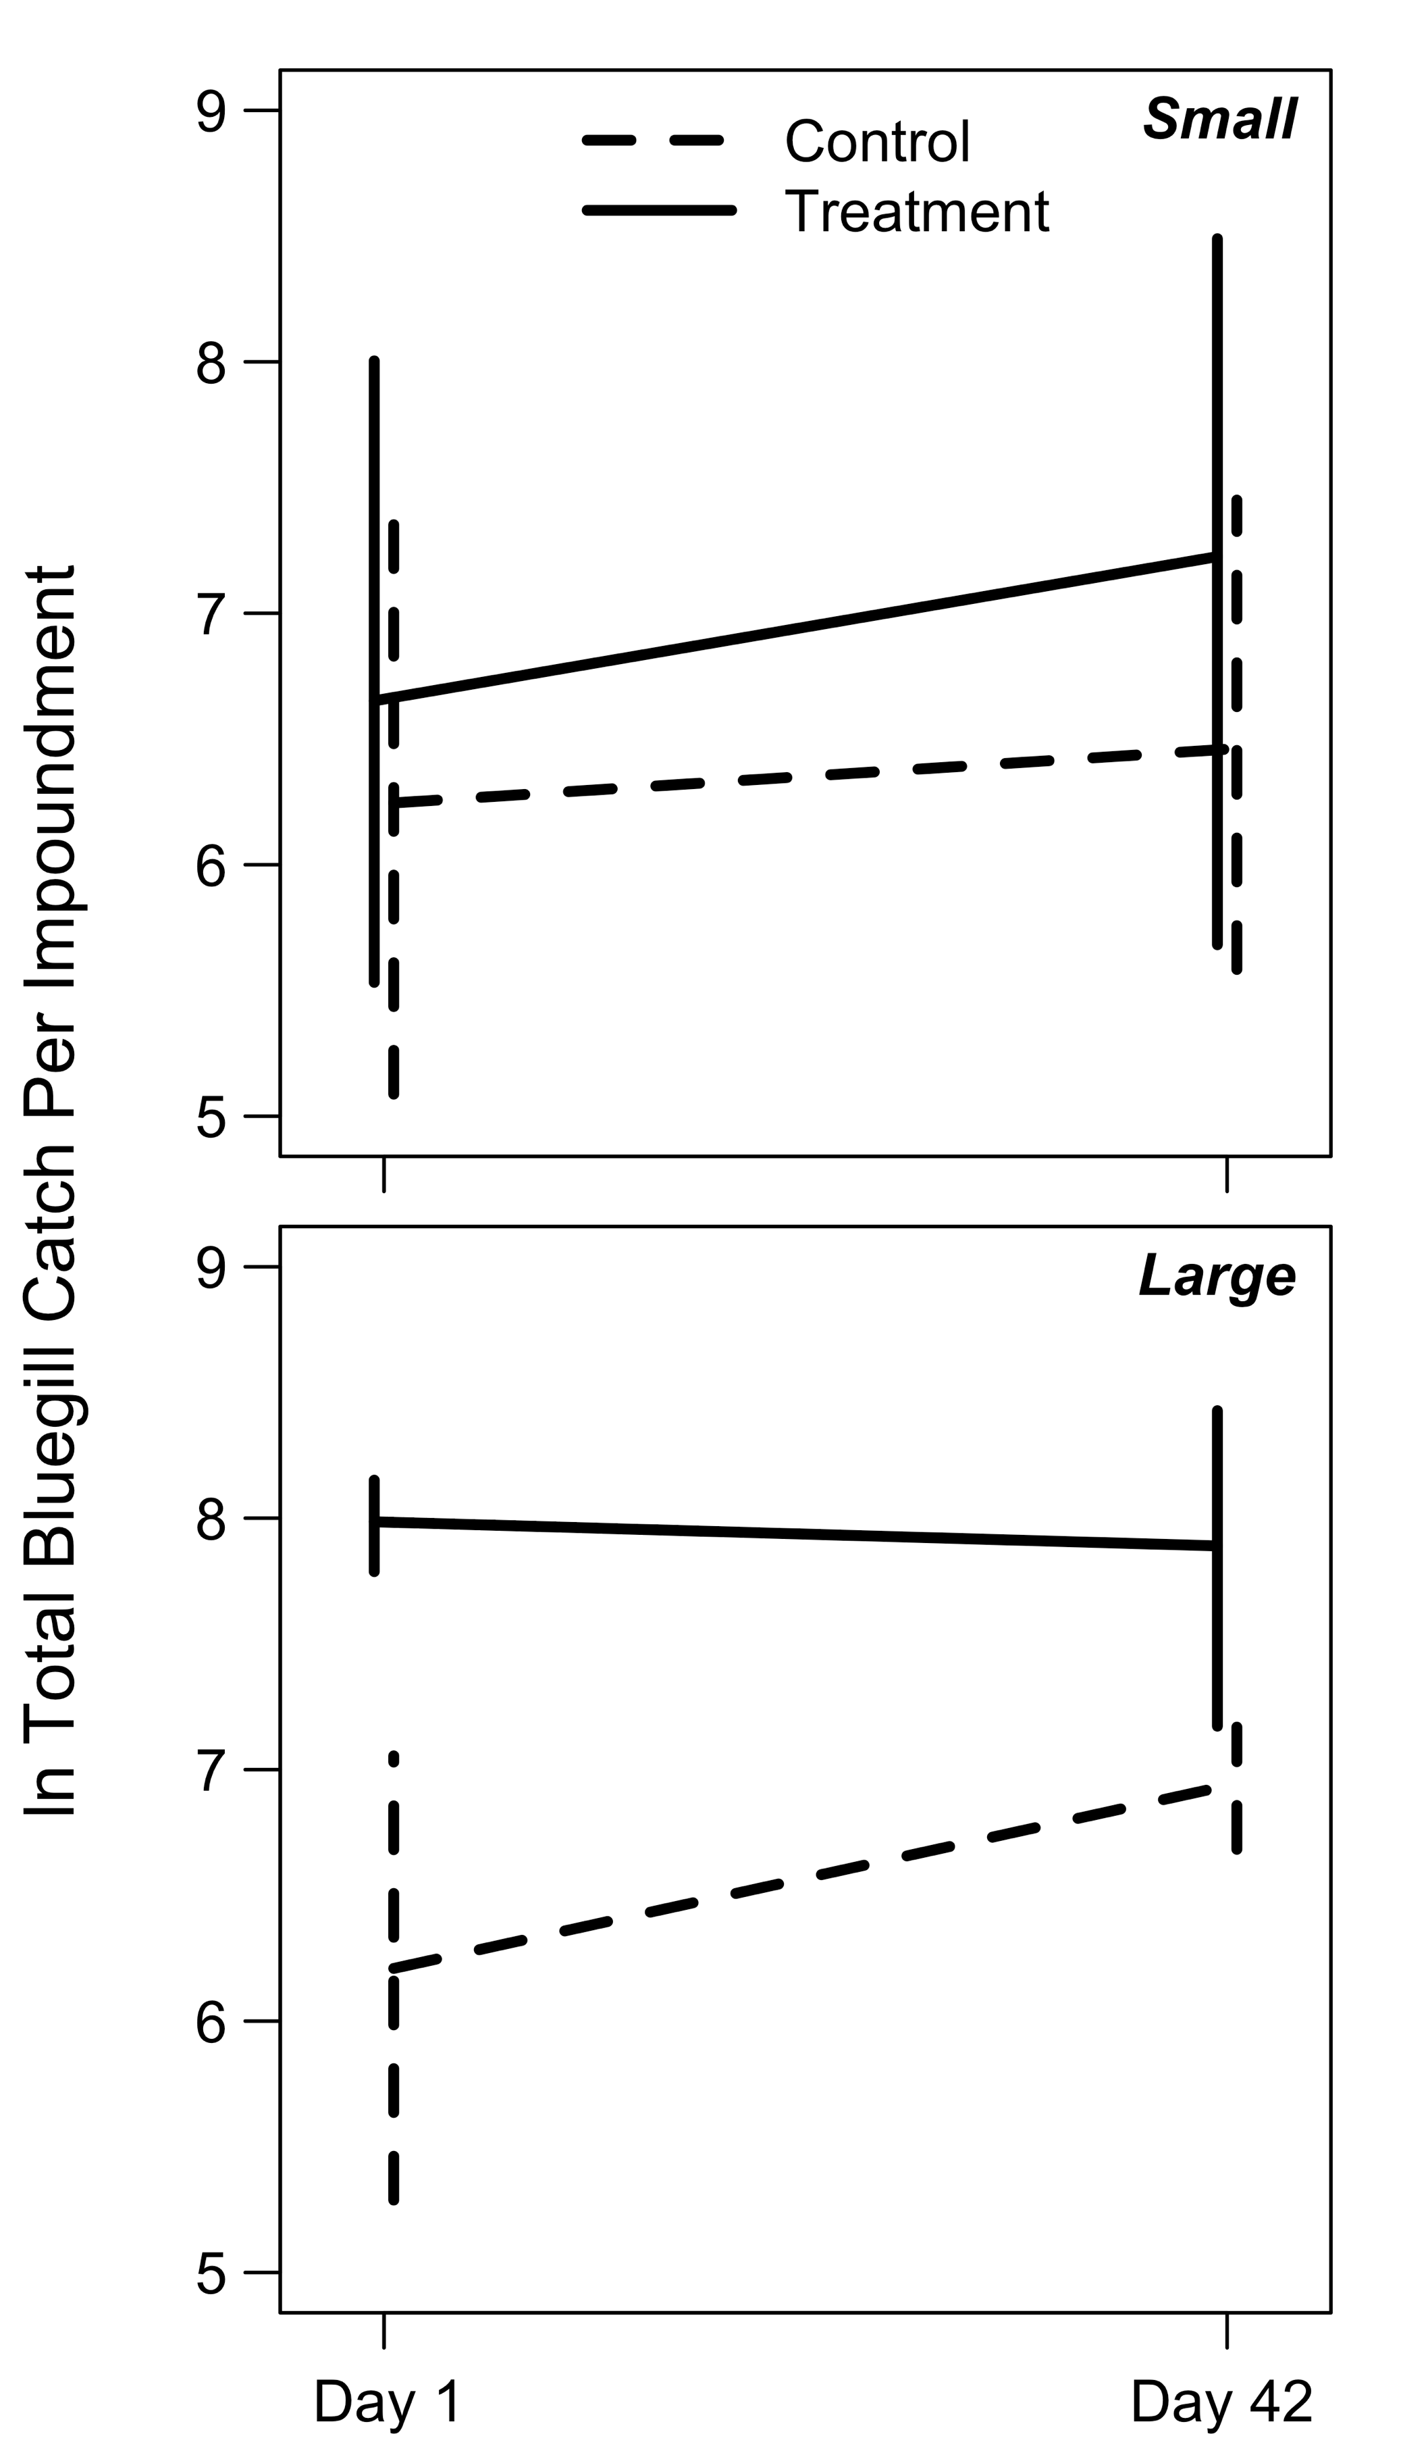

Figure 5.

Bluegill loge total seine catches in small (<12 ha; upper panel) and large (>33 ha; lower panel) impoundments immediately before rotenone application (day 1) and at mid-summer after both rotenone applications (day 42). Data are presented as in Figure 4.

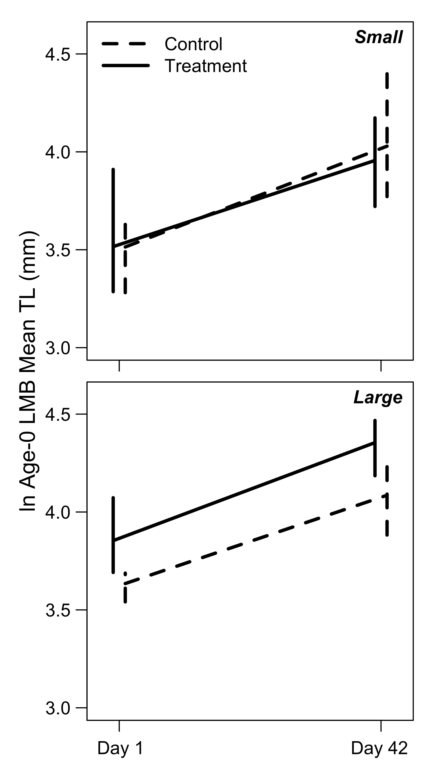

Figure 6.

Largemouth Bass loge MLA-0 in small (<12 ha; upper panel) and large (>33 ha; lower panel) impoundments immediately before rotenone application (day 1) and at mid-summer after both rotenone applications (day 42). Data are presented as in Figure 4.

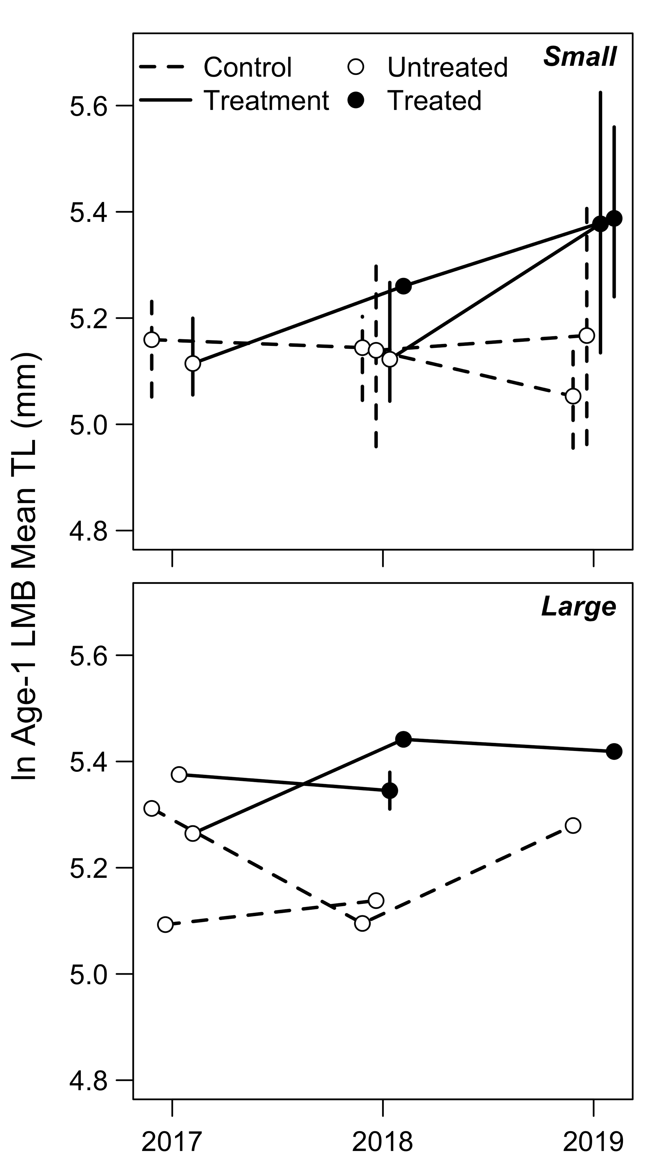

Figure 7.

Temporal trends in Largemouth Bass loge MLA-1 in small (<12 ha; upper panel) and large (>33 ha; lower panel) impoundments in control (dashed lines) and treatment (solid lines) impoundments. Open circles denote untreated impoundments, while closed circles denote treated impoundments. Solid lines leading from a closed circle to another closed circle represent the impoundments that were treated twice (e.g., see Table 1). Times treated (untreated control, once, twice) was the variable of interest in our model, and this portrays how the model compared those different levels of treatment. Error bars represent the 95% confidence intervals of the data when the sample size for that year was greater than two impoundments.

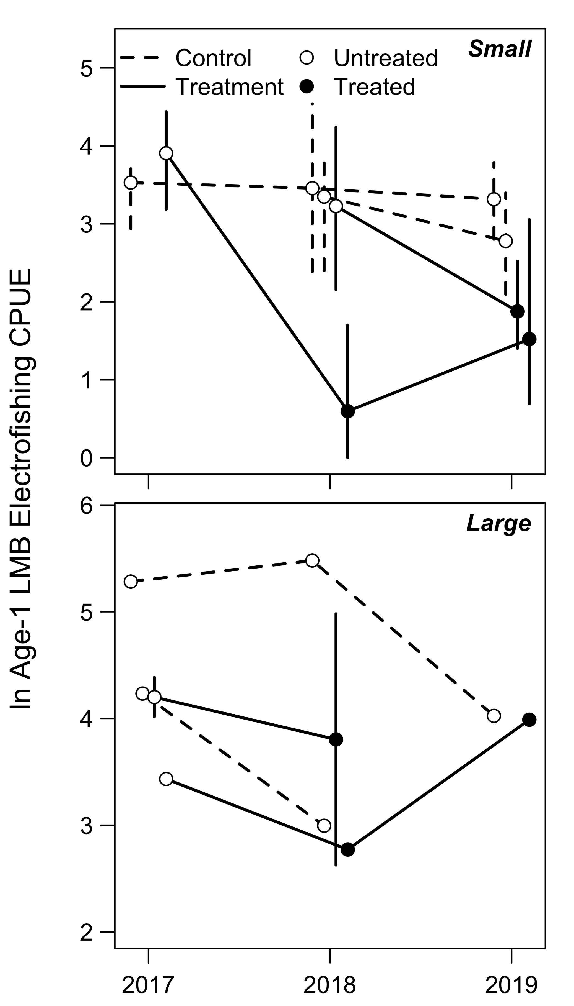

Figure 8.

Temporal trends in age-1 Largemouth Bass loge electrofishing CPUE (fish caught per 30 minutes electrofishing)—as a proxy for recruitment—in small (<12 ha; upper panel) and large (>33 ha; lower panel), and control (dashed lines) and treatment (solid lines) impoundments. Open circles denote untreated impoundments, while closed circles denote treated impoundments. Data are presented as in Figure 7.

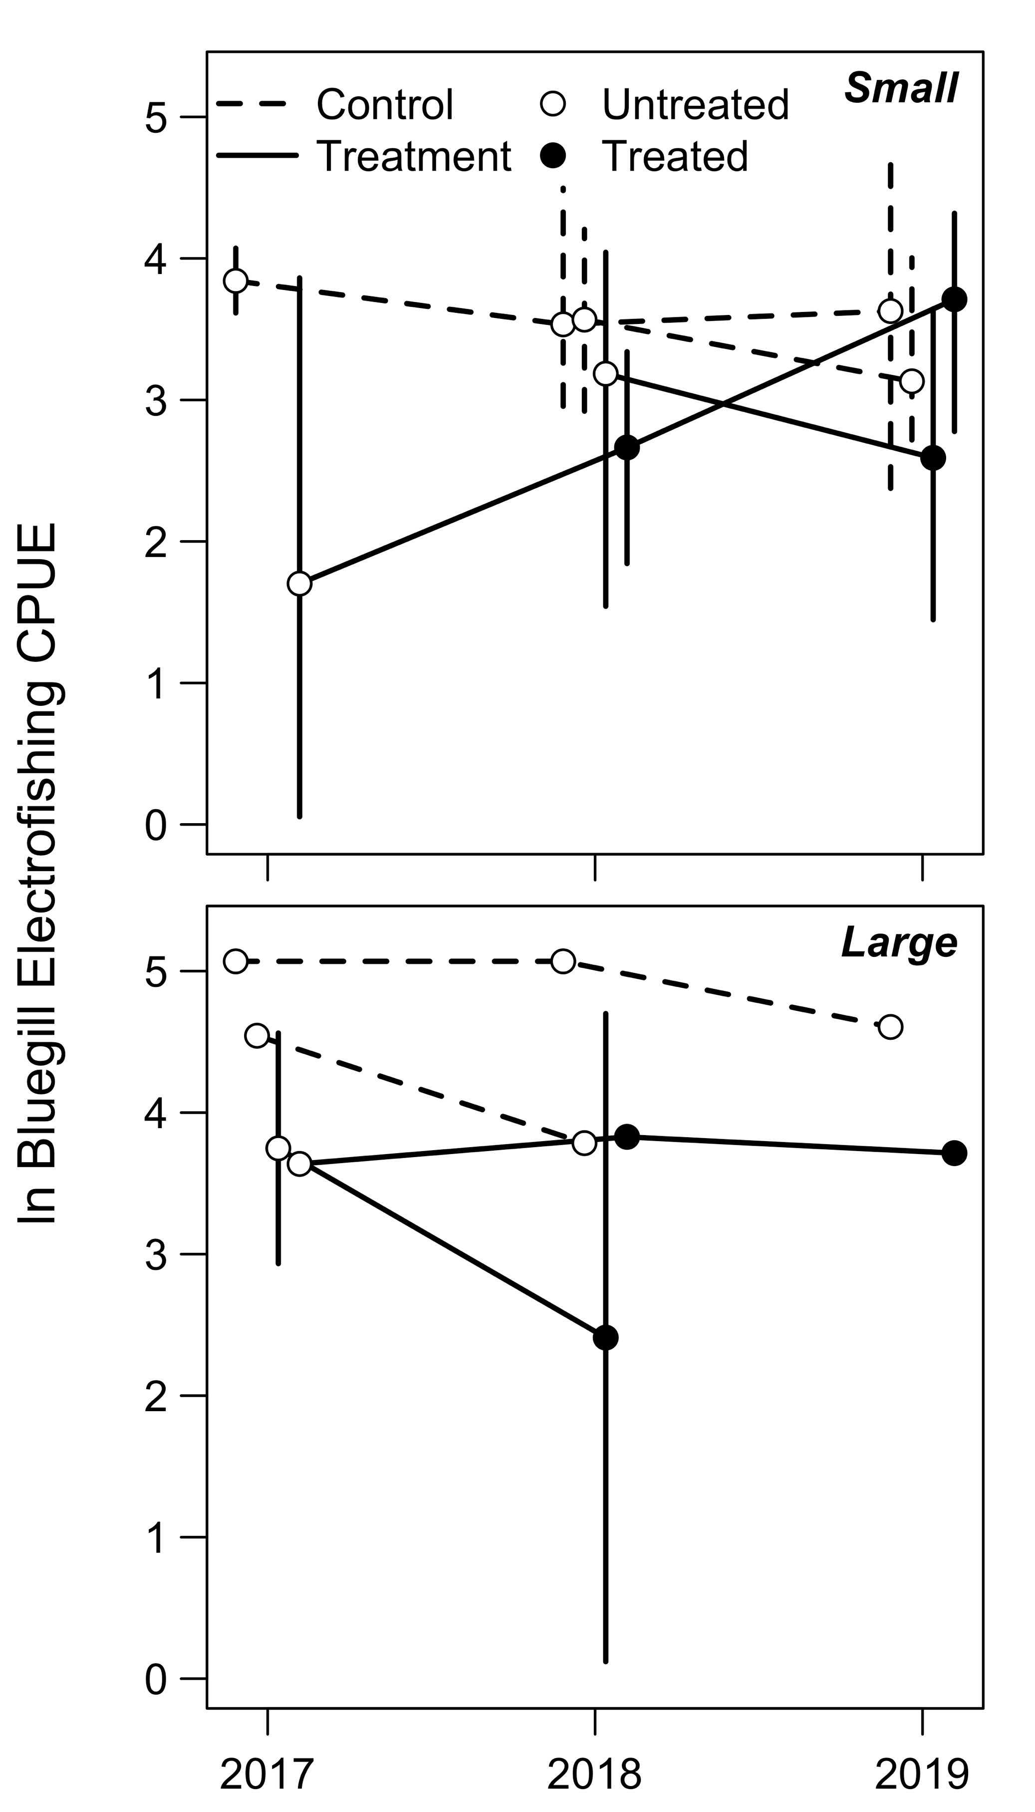

Figure 9.

Temporal trends in Bluegill (>80 mm) loge electrofishing CPUE (fish caught per 30 minutes electrofishing) in small (<12 ha; upper panel) and large (>33 ha; lower panel), and control (dashed lines) and treatment (solid lines) impoundments. Open circles denote untreated impoundments, while closed circles denote treated impoundments. Data are presented as in Figure 7.